**Use Case**

1. Download S&P500 stock prices from Yahoo Finance <https://finance.yahoo.com/> using this period : 1/1/1950 to 7/26/2019
2. Save as returns.csv file
3. Calculate daily returns
4. Run the simulation.py code
5. Get the following results

**Results**

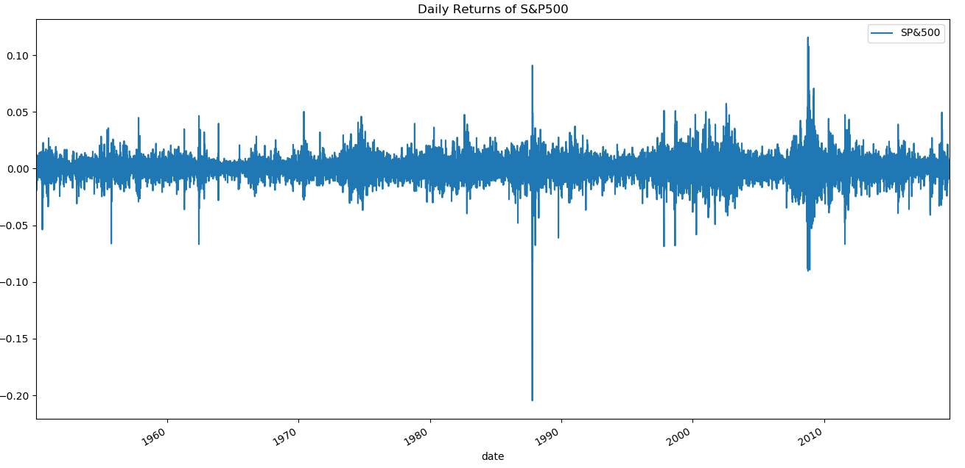**Figure. Historical daily returns of the S&P500 during the 1987 and 2008 financial crisis**

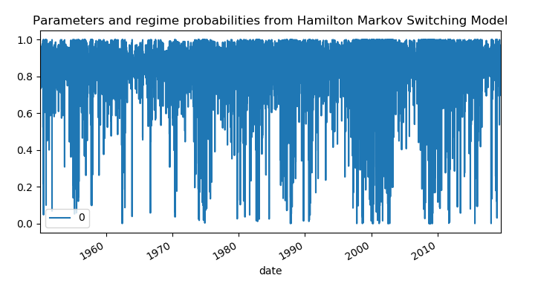

**Figure. Smoothed probabilities over the in-sample period. The blue area indicate a smoothed probability of regime 1 respectively 2 exceeding 0.5: two regimes**

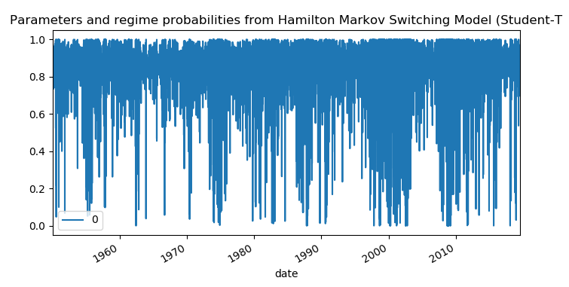

**Figure. Smoothed probabilities over the in-sample period. The blue area indicate a smoothed probability of regime 1 respectively 2 exceeding 0.5: three regimes**

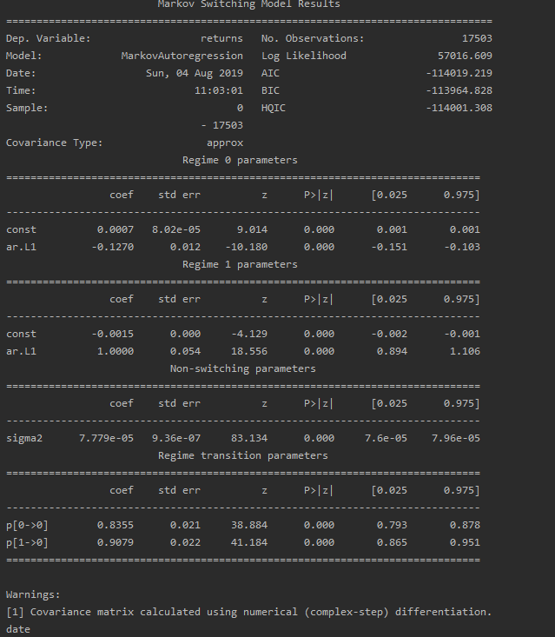

**Figure. Estimate of the MS model using SP500 daily returns data set: Gaussian Distribution**

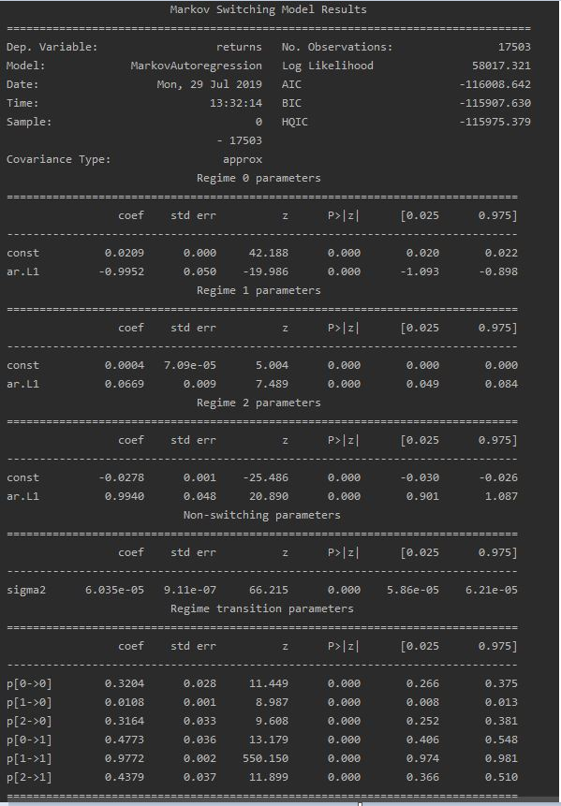

**Figure. Estimate of the MS model using SP500 daily returns data set: Student-T Distribution**